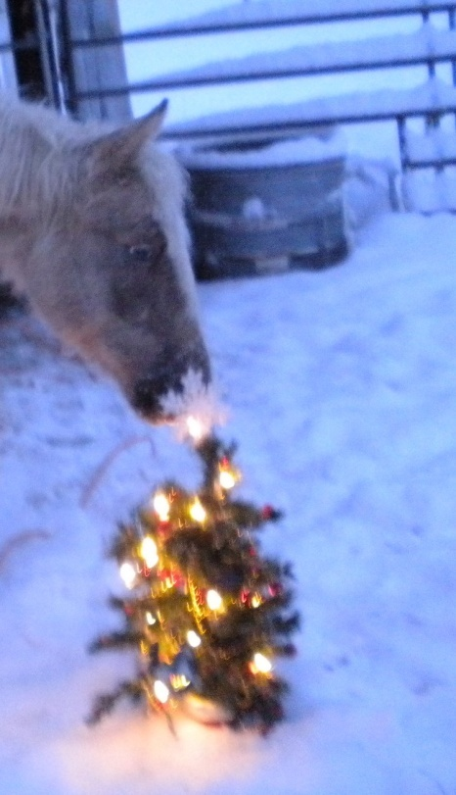A Christmas Wish

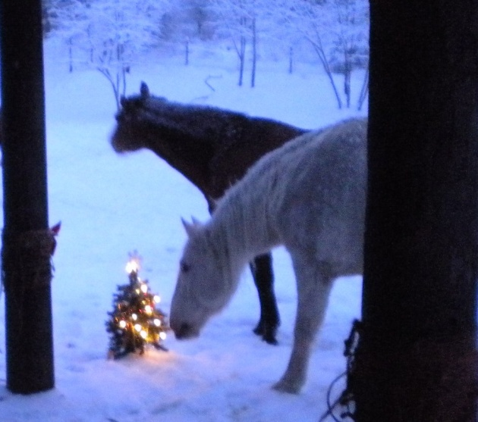from all the horses at EZ Stables to you.

***May Christmas always be amazing***

***That everyday there's some-thing exciting in your life***

***(The horses did all the acting and Modeling themselves)***

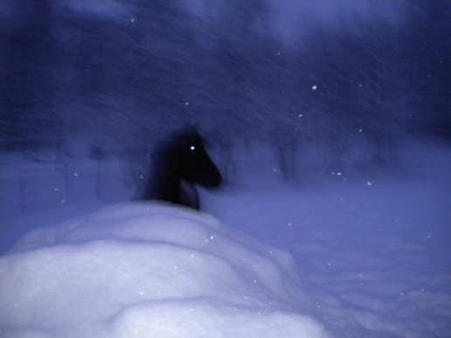

***Watch for Opportunities***

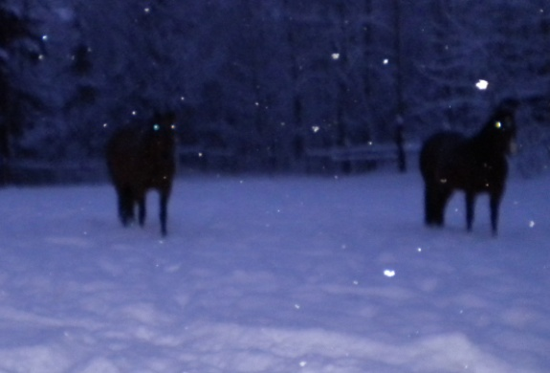

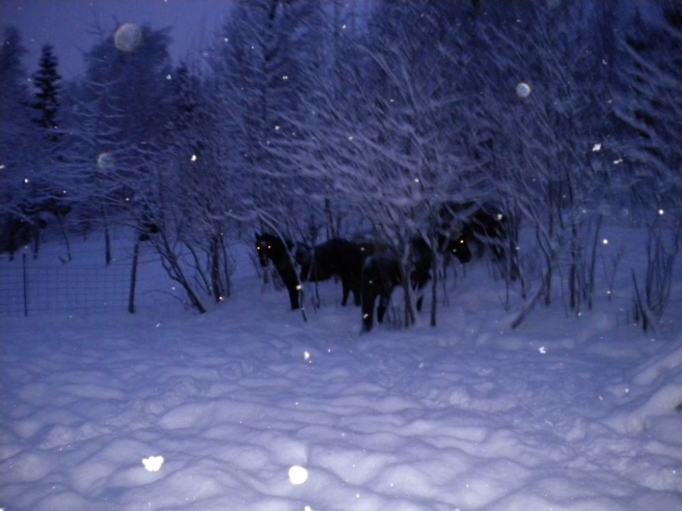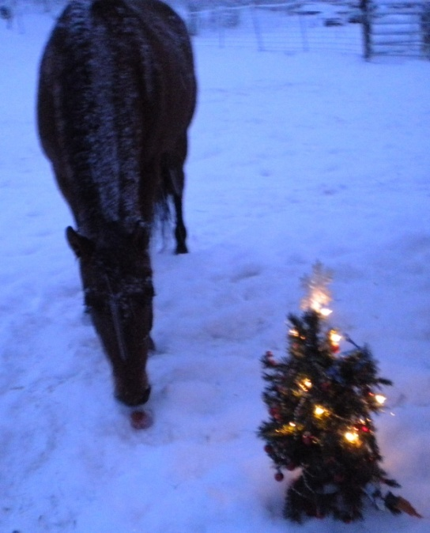

***Hope you have friends to stand by you and Snow that makes you laugh***

***You have many surprises to be thankful for***

***You always Look for the good things.***

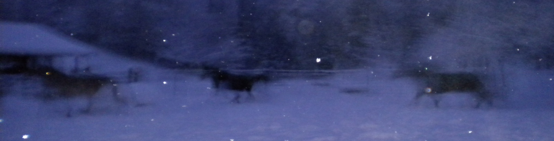

Merry Christmas, hope a new year finds you on a Horse and in Motion!!!!.